**15th September 2022.**

**Services Page Images and short write up**

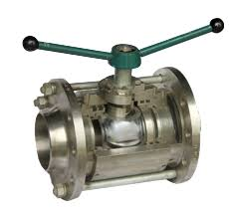

Model KH 11 – S //

Nuclear power applications demands a high corrosive resistant materials with robust design for long lasting service life.

Perrin KH 11- S ball valve design features a three piece body and a floating, seat supported ball. The stem packing is spring loaded and the seat rings with pressure relief warranty are pre-loaded. Stem extensions, locking devices and actuators with accessories, can be attached without

operating interruptions.

|  |  |
| --- | --- |
| **SALIENT FEATURES** | |
| **Size Range** | **1/2 - 4 inch / DN 15 – 100** |
| **Pressure Class** | **Class 150 – 300** |
| **Temperature Range** | **-60°C to 200°C** |
| **Testing Standards** | **API 598, EN 12266 – 1/2** |
| **Certificates** | **‘TA – Luft’ Low Fugitive Emission** |
| **Actuator Mounting as per** | **ISO 5211** |
| **Design Standards** | **API 608, EN 12516, AD-2000, ASME B 16.34** |
| **Stem** | **Blow out proof stem, Live loaded stem packing** |

Nuclear Power Valves

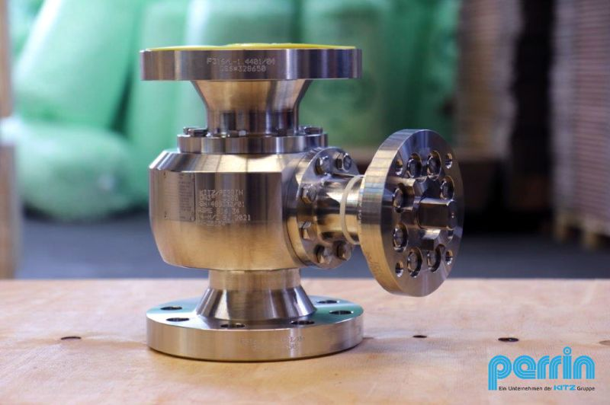

Model KH – 14 M ///

Process industries demands some critical requirements of ball valves for its continuous operations, Perrin 14 – M ball valves is a 2 – way split body design with 3 point redundant position indication. This provides maximum safety for position indication of the valve and hence complete process.

This ball valves can work efficiently in various service applications such as Warm – up, Quench and Drain, Blow-down, bypass, Overhead vapour or Coker drum isolation.

Design of ball valve features a two piece, bolted body and a trunnion mounted ball. The metallic seat

system and the stem packing are spring loaded, resulting in very good sealing properties and a constant torque not influenced by temperature fluctuations.

Stem extensions, locking devices and actuators with accessories can be field mounted at any time.

|  |  |
| --- | --- |
| **SALIENT FEATURES** | |
| **Size Range** | **1 - 24 inch / DN 25 – 600** |
| **Pressure Class** | **Class 150 – 2500** |
| **Temperature Range** | **-60°C to 550°C** |
| **Testing Standards** | **API 598, EN 12266 – 1/2** |
| **Certificates** | **‘TA – Luft’ Low Fugitive Emission** |
| **Actuator Mounting as per** | **ISO 5211** |
| **Design Standards** | **API 608, EN 12516, AD-2000, ASME B 16.34** |
| **Stem** | **Blow out proof stem, Live loaded stem packing, Spring loaded seat system** |

All Round Valves

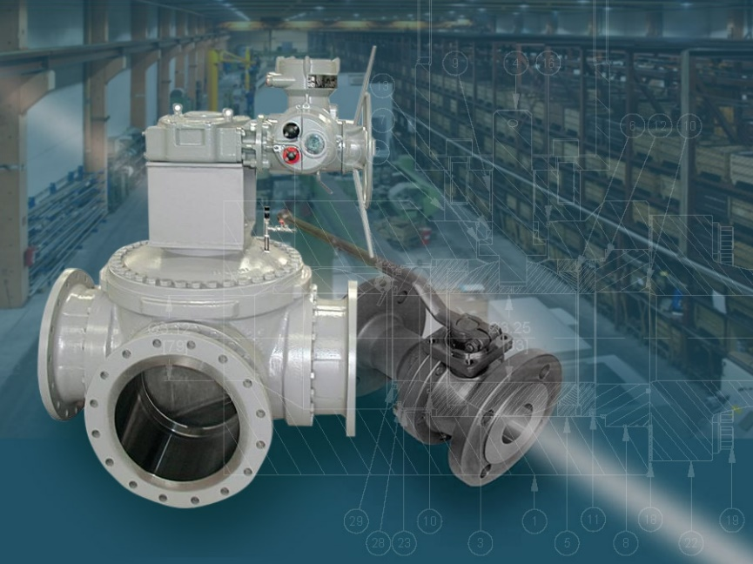

Model KH 75 (2 – way valve)

Model KH 20

Model KH 25 (3 – way valve)

Model KH 23 (4 – way valve)

Model KH 24 (Multiway valve)

Perrin 2- Way ball valves for general chemical applications are with floating ball and designed with a 2- or 3-piece body. The floating design creates a tightness on the outlet side which increases further with an increase of the pressure on the upstream side.

The trunnion mounted multi-way Ball Valves are equipped with a 2-component or 3-component body. Spring-loaded seats are used for sealing. Due to the absorption of force by the trunnion and stem the trunnion mounted Ball Valve not only has less torque than the floating versions, but is also suitable for larger sizes and higher pressure levels. The ball and stem are made in one piece, so that even with a high switching frequency, no slackness and resulting wear can occur on these components’ connectors. The balls are equipped with different bores (e.g. L, T or X) depending on the model, so customized solutions for the distribution of media are available.

General Chemical Valves

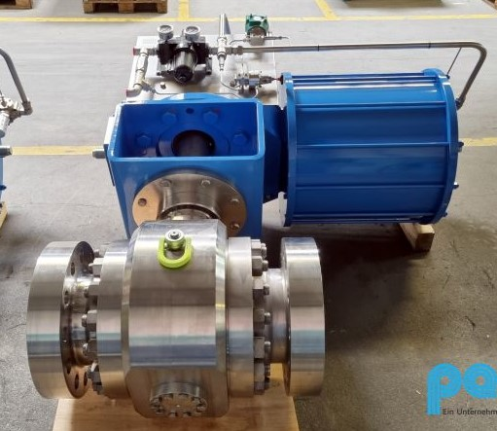

Model KH 16 – M //

Perrin high cycle ball valves are specially designed for withdrawal and discharge of batch wise polymer product from fluidised bed reactor. On off valves has to continuously operate (open / close) at least 12- 14 times in an hour, opening and closing time of valves is < 1 sec.

This ball valves are equipped with 3-piece body (easy for disassembly and cleaning), Dust protected spring area, Special Bearing design for up to 1 Mill. strokes

Trunnion mounted ball design with integral stem (the result is no clearance between the ball and stem connection) the surfaces of the ball, seat and bearings are coated for longer service life.

|  |  |
| --- | --- |
| **SALIENT FEATURES** | |
| **Size Range** | **1 - 12 inch / DN 25 – 300** |
| **Pressure Class** | **Class 150 – 1500** |
| **Temperature Range** | **-60°C to 550°C** |
| **Testing Standards** | **API 598, EN 12266 – 1/2** |
| **Certificates** | **‘TA – Luft’ Low Fugitive Emission** |
| **Actuator Mounting as per** | **ISO 5211** |
| **Design Standards** | **API 608, EN 12516, AD-2000, ASME B 16.34** |
| **Stem** | **Blow out proof stem, Live loaded stem packing, Spring loaded seat system** |

High Open / Close Cycle Valves

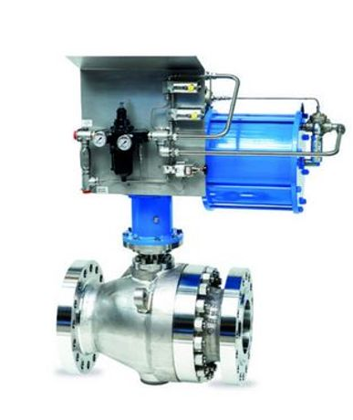

Purified Terepathelic Acid (PTA) is a white crystalline powder, which is used for the production of PET (polyethylene terephthalate). PET is required, for example for the production of the known PET beverage bottles, films / resins, filament yarns & fibres.

Perrin offers & delivers ball valves for PTA plants that are planned and built according to the special license.

Perrin KH – 70 M ball valve design features a two piece body and a floating, seat supported ball. The stem packing is spring loaded and the metal seat rings are pre-loaded. Stem extensions, locking devices and actuators with accessories, can be attached without operating interruptions.

|  |  |
| --- | --- |
| **SALIENT FEATURES** | |
| **Size Range** | **½ - 12 inch / DN 15 – 300** |
| **Pressure Class** | **Class 150 – 300** |
| **Temperature Range** | **-60°C to 450°C** |
| **Testing Standards** | **API 598, EN 12266 – 1/2** |
| **Certificates** | **‘TA – Luft’ Low Fugitive Emission** |
| **Actuator Mounting as per** | **ISO 5211** |
| **Design Standards** | **API 608, EN 12516, AD-2000, ASME B 16.34, EN 1983** |
| **Stem** | **Blow out proof, Live loaded stem packing** |

Model KH – 70 M ///

PTA / Pharmaceutical Valves

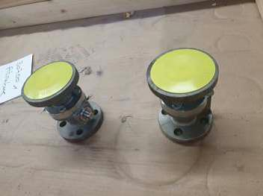

Model KH 80 M ///

Model KH 85 M ///

This is ball valves are generally used for hot and abrasive service media, different combination of material in casting or forging like Stainless steel, Carbon steel are available as per medium like gas, liquid or slurry.

Perrin KH – 80 ball valves is a two piece split body housing with floating ball design. Valves are equipped with spring loaded spring system and live loaded stem packing which provides tightness during rapid temperature changes.

Stem extensions, locking devices and actuator accessories can be attached without operating interruptions.

|  |  |
| --- | --- |
| **SALIENT FEATURES** | |
| **Size Range** | **1/2 - 12 inch / DN 15 – 300** |
| **Pressure Class** | **Class 150 – 1500** |
| **Temperature Range** | **-60°C to 450°C** |
| **Testing Standards** | **API 598, EN 12266 – 1/2** |
| **Certificates** | **‘TA – Luft’ Low Fugitive Emission** |
| **Actuator Mounting as per** | **ISO 5211** |
| **Design Standards** | **API 608, EN 12516, AD-2000, ASME B 16.34; EN 1983** |
| **Stem** | **Blow out proof stem, Live loaded stem packing, Spring loaded seat system** |

**Vaccum Service Valves**

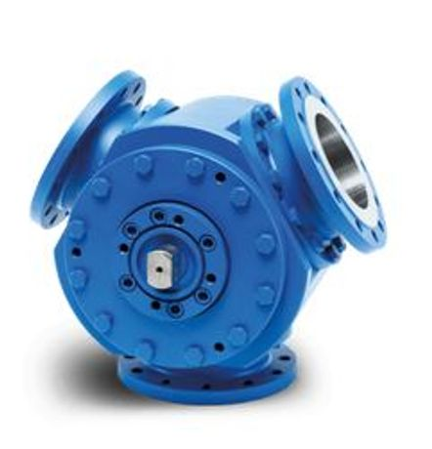

Flanged 120° diverter ball valves trunnion type with mobile seat seals, this valves has been successfully installed under polymer and powder service medium for Polypropylene and PE projects globally. This valves are supplied with manually operated gearbox or automated with pneumatic or hydraulic actuators as per customer specifications.

Perrin KH 22 M ball valve has twin bearing ball with integral stem and split body housing. The ball valve has anti-static design. Stem packing and sealing are “TA – Luft” certified for low fugitive emissions.

|  |  |
| --- | --- |
| **SALIENT FEATURES** | |
| **Size Range** | **1/2 - 20 inch / DN 15 – 500** |
| **Pressure Class** | **Class 150 – 1500** |
| **Temperature Range** | **-60°C to 550°C** |
| **Testing Standards** | **API 598, EN 12266 – 1/2** |
| **Certificates** | **‘TA – Luft’ Low Fugitive Emission** |
| **Actuator Mounting as per** | **ISO 5211** |
| **Design Standards** | **API 608, EN 12516, AD-2000, ASME B 16.34, EN 1983** |
| **Stem** | **Ball with integral stem and twin bearing, Live loaded stem packing, Spring loaded seat system** |

Model KH – 22 M ///

Polypropylene / P.E. Valves

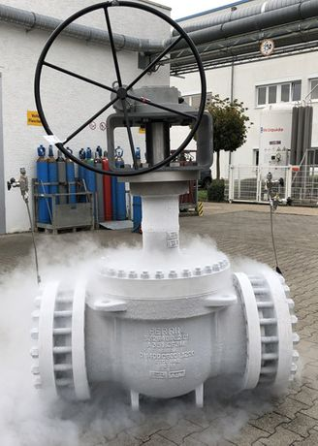

Model KH 64 K ///

Model KH 67 K ///

Our Top-Entry Valve can be designed with either floating or trunnion mounted balls. Due to the stem extension and the chosen seat rings, the ball valve can be used for cryogenic temperatures down to -196°C. The special seat ring design tolerates the Bi-directional application up to full differential pressure. Top entry valves can be directly welded to pipeline without any damages to internals.

|  |  |
| --- | --- |
| **SALIENT FEATURES** | |
| **Size Range** | **1 - 8 inch** |
| **Pressure Class** | **Class 150 – 900** |
| **Temperature Range** | **-196°C to 100°C** |
| **Fugitive Emission as per** | **ISO – 15848 - 1** |
| **Fire safe tested as per** | **ISO 10497, API 607** |
| **Design Standards** | **BS 6364, EN 1626, ISO28921, OCIMF** |
| **Stem** | **Blow out proof stem, Anti-static design** |

Top Entry Ball Valves

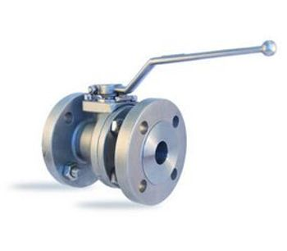

Model KH – 88 M //

Mining, Solid Medium Valves

The Perrin ball valve is a floating ball design with a two piece split body housing. The spring loaded metallic seat system and live loaded stem packing also provide continuous tightness during short-term temperature and pressure changes. The ball valve is specially designed for transportation of severe solids and high-viscosity fluids such as slurry.

The maximum differential pressure for operating depends on the chosen nominal size and pressure

rating and will be decided within the order. Stem extensions, locking devices and actuators with accessories, can be attached without operating interruptions.

|  |  |
| --- | --- |
| **SALIENT FEATURES** | |
| **Size Range** | **2 -24 inch / DN 50 – 600** |
| **Pressure Class** | **Class 150 – 2500** |
| **Temperature Range** | **-60°C to 450°C** |
| **Testing Standards** | **API 598, EN 12266 – 1/2** |
| **Certificates** | **‘TA – Luft’ Low Fugitive Emission** |
| **Actuator Mounting as per** | **ISO 5211** |
| **Design Standards** | **API 608, EN 12516, AD-2000, ASME B 16.34; EN 1983** |
| **Stem** | **Blow out proof stem, Live loaded stem packing, Spring loaded seat system** |

KH – 15 M

Tank Bottom Valve

This PERRIN ball valve design features a two piece, bolted body and a trunnion mounted ball. The seat system and the stem packing are spring loaded, resulting in very good sealing properties and a constant torque not influenced by temperature fluctuations. By using the larger inlet-flange the clearance volume above the ball can be reduced to a minimum.

The actuator mounting flange corresponds to the NAMUR recommendations with dimensions to DIN/ISO 5211.

Stem extensions, locking devices and actuators with accessories can be field mounted at any time.

|  |  |
| --- | --- |
| **SALIENT FEATURES** | |
| **Size Range** | **1 - 12 inch / DN 25 – 300** |
| **Pressure Class** | **Class 150 – 2500** |
| **Temperature Range** | **-60°C to 450°C** |
| **Testing Standards** | **API 598, EN 12266 – 1/2** |
| **Certificates** | **‘TA – Luft’ Low Fugitive Emission** |
| **Actuator Mounting as per** | **ISO 5211** |
| **Design Standards** | **API 608, EN 12516, AD-2000, ASME B 16.34** |
| **Stem** | **Blow out proof stem, Live loaded stem packing, Spring loaded seat system** |